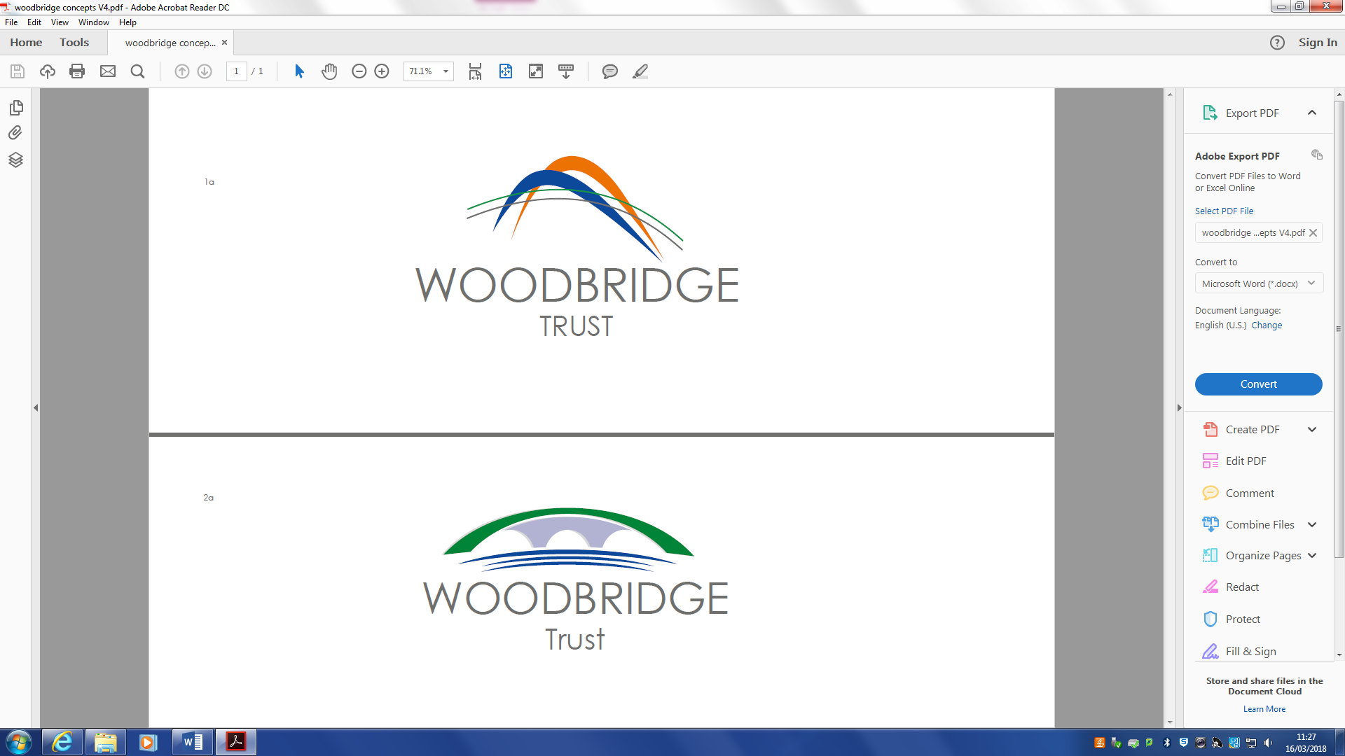

**WOODBRIDGE TRUST LIST**

**OF TRUST WIDE POLICIES**

**The following list of policies will be applied across Woodbridge Trust and will be updated as stated.**

**This list may be added to and policies removed if superseded by subsequent policies.**

**Each school will have in addition to these their bespoke policies contextualised to the setting and needs of the children and young people which can be asked for on request.**

**Reviewed and Updated List September 2023**

|  |  |  |  |  |
| --- | --- | --- | --- | --- |
| **Name of Policy** | **Created**  **By** | **Start**  **Date** | **Review Timescale** | **Next Review Date** |
| Accessibility – Trust Wide Ethos | Woodbridge Trust | Sept 2022 | 3 Years | Sept  2025 |
| Adoption Policy | Bolton LA | July 2017 | As Required by LA |  |
| Alcohol & Drugs | Bolton LA | Nov 2016 | As Required by LA |  |
| Anti-Bullying Policy | Woodbridge Trust | Sept 2023 | Annually | Sept  2024 |
| Anti-Fraud Policy | Woodbridge Trust | April 2021 | 3 years | April  2024 |
| Appraisal & Performance Mgt | Bolton LA | Nov 2022 | As Required by LA |  |
| Bereavement | Bolton LA | Dec 2019 | As Required by LA |  |
| Charging & Remissions | Bolton LA | Nov 2019 | As Required by LA |  |
| Clear Desk & Screen | Bolton LA | Sept 2023 | Annually | Sept  2024 |
| Complaints Policy | Woodbridge Trust | Dec 2020 | 3 years | Dec  2023 |
| Conflict of Interest Policy | Woodbridge Trust | Oct 2022 | 3 years | Oct  2025 |
| Dinner Money | Woodbridge Trust | Sept  2023 | Ann Review | Sept  2024 |
| Disciplinary & Dismissal | Bolton LA | Dec 2016 | As Required by LA |  |
| Domestic Violence | Bolton LA | Aug 2016 | As Required by LA |  |
| Dress Code | Woodbridge Trust | Sept 2022 | 3 Years | Sept  2025 |
| Environmental Policy | Woodbridge Trust | Oct 2022 | 3Years | Oct  2025 |
| Exclusions and Suspensions Policy | Woodbridge Trust | July 2023 | Ann Review | July  2024 |
| Equality | Bolton LA | July 2017 | As Required by LA |  |
| Fixed Term Contract | Bolton LA | Jan 2017 | As Required by LA |  |
| Flexible Working | Bolton LA | June  2021 | As Required by LA |  |
| Grievance | Bolton LA | Nov 2022 | As Required by LA |  |
| **Name of Policy** | **Created**  **By** | **Start**  **Date** | **Review Timescale** | **Next Review Date** |
| Guidance on Use of Laptops/ iPads | Woodbridge Trust | Sept 2022 | 3 Years | Sept  2025 |
| Job Share | Bolton LA | Aug 2016 | As Required by LA |  |
| Leave of Absence | Bolton LA | May 2019 | As Required by LA |  |
| Local Government Pensions Discretionary Policy | Bolton LA | Sept 2022 | Annually | Sept  2023 |
| Lone Working Policy | Bolton LA | Sept 2022 | 3 Years | Sept  2025 |
| Managing Support staff Capability | Bolton LA | Nov 2022 | As Required by LA |  |
| Managing Teachers Capability | Bolton LA | Nov  2022 | As Required by LA |  |
| Maternity | Bolton LA | Jan 2018 | As Required by LA |  |
| Overpayment & Underpayment of Salary | Bolton LA | Jan 2017 | As Required by LA |  |
| Paternity | Bolton LA | July 2017 | As Required by LA |  |
| Probationary Period Policy & Guidance | Bolton LA | Nov 2022 | As Required by LA |  |
| Redundancy | Bolton LA | April 2022 | As Required by LA |  |
| **Safeguarding & CP (Each school / setting has own)** | Woodbridge Trust/ LA |  | Annually  Within Each School / Setting |  |
| Safeguarding/ Disclosure & Barring | Bolton LA | Nov 2022 | As Required by LA |  |
| Safer Recruitment **Guidance** | Bolton LA | Oct 2015 |  | For Guidance Only |
| SEND | Woodbridge Trust | Sept 2023 | Annually | Sept  2024 |
| Severe Weather | Bolton LA | Jan 2017 | As Required by LA |  |
| Shared Parental Leave Pay | Bolton LA | April 2016 | As Required by LA |  |
| **Name of Policy** | **Created**  **By** | **Start**  **Date** | **Review Timescale** | **Next Review Date** |
| Sickness Absence Policy | Bolton LA | Nov 2022 |  |  |
| Social Networking | Bolton LA | Jun  2018 | Annually- via Trust | Sept  2024 |
| Staff Code of Conduct | Woodbridge Trust | Sept 2023 | Annually | Sept  2024 |
| Subject Leadership | Woodbridge Trust | Nov 2019 | As Required by Trust |  |
| Teaching & Learning Protocols | Woodbridge Trust | Sept 2023 | Annually | Sept  2024 |
| Transgender | Bolton LA | Oct 2017 | As Required by LA |  |
| Whistleblowing | Bolton LA | Nov 2018 | As Required by LA |  |
| Woodbridge College  Finance Policy | Woodbridge Trust | Oct 2022 | Annually | Oct  2023 |
| Woodbridge Trust Information Management Policy | Bolton LA | Nov 2018 | As Required  by LA |  |
| Woodbridge Trust Asbestos Management | Woodbridge Trust | Sept 2023 | Annually | Sept  2024 |
| Woodbridge trust COSHH Policy | Woodbridge Trust | Sept  2023 | Annually | Sept  2024 |
| Woodbridge Trust Dinner Money Policy | Woodbridge Trust | Sept 2023 | Annually | Sept  2024 |
| Woodbridge Trust Finance Policy | Woodbridge Trust | Oct  2022 | Annually | Oct  2023 |
| Woodbridge Trust Fire Safety Policy | Woodbridge Trust | Sept 2023 | Annually | Sept  2024 |
| Woodbridge Trust Pay Policy | Bolton LA | Nov 2022 | Annually |  |
| Woodbridge Trust Procurement Policy | Woodbridge Trust | Oct 2022 | Annually | Oct  2023 |
| Workplace Stress | Bolton LA | June 2017 | As Required by LA |  |

* Each school and setting to have its’ own Safeguarding / CP policy bespoke to the needs of the children and young people and based on the Keeping Children Safe in Education 2023. Each member of staff employed by the school / setting should have received Part 1 as a document to be read and signed for. The new policy to be adopted is typically circulated to schools by the Bolton Safeguarding Team each September and must be published on the website.